Child Care Guidance

**Build a Raft**

1. Each team receives 10 drinking straws, 25 inches of masking tape and 1   
 pair of scissors.

2. The object is to construct a raft that will hold the most pennies before   
 sinking. You may only use the straws and tape given. You cannot test the   
 raft before the official float.

3. You have 7 minutes to construct the raft. When time is up, we will do an   
 official float test for each raft, having the team members add one penny at a   
 time to your raft.

4. The raft that holds the most pennies before sinking is the winner.

5. When everyone is finished you will complete the discussion guide.

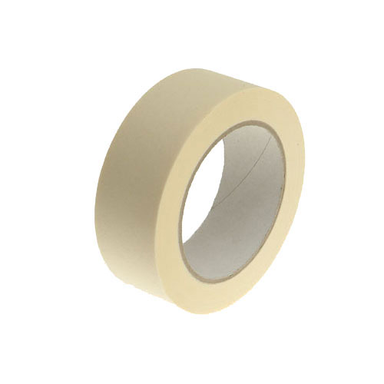[](http://www.google.com/url?sa=i&rct=j&q=&esrc=s&frm=1&source=images&cd=&cad=rja&docid=kgaju9IwEXTz-M&tbnid=b4cMvUxBGcw3tM:&ved=0CAUQjRw&url=http://openclipart.org/detail/25380/scissors-half-open-icon-by-pitr-25380&ei=dCUFUsvQGObOyAGd_IAg&bvm=bv.50500085,d.aWc&psig=AFQjCNGZQ8va9Uw2PYerH7w7M4t9P-TXEg&ust=1376155309563615)