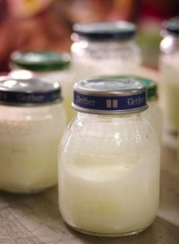
Background Information
Invisible fat in cream can be turned into visible fat by agitating it. Through agitation, the fat droplets coalesce, or come together to form globules. As agitation continues, the globules get larger and larger until they separate from the liquid. In this experiment, you will make butter from cream by shaking the cream in a jar with a marble. The marble helps to increase the agitation, speeding up the process.
Procedure
1. Observe the condition of the cream, noting its color and texture. Pour a small sample of cream into
a drinking cup and taste it, noting its texture and flavor. Record your observations in the proper
blanks on the Observation Chart. Discard any leftover cream from the tasting sample.
2. Place 1 cup cream and marble in glass jar.
3. Screw the lid on the jar tightly.
4. Shake jar vigorously.
5. When the fat coalesces into a ball of butter, drain off the liquid, called buttermilk, into a glass.
6. Remove the marble from the jar and examine it closely for chips. Discard the butter if you see any
chips.
7. Place butter into a bowl. Squeeze butter against the side of the bowl with a wooden spoon or
rubber scraper to press out the buttermilk.
Observations
1. Observe the color and texture of the butter you made. Record your observations in the proper
blanks on the Observation Chart.
2. Taste the butter. Record your observations regarding texture and flavor on the Observation Chart.
3. Observe the buttermilk you made. Record your observations regarding its color and texture on the
Observation Chart.
4. Taste the buttermilk. Record your observations regarding texture and flavor in the proper blanks on
the Observation Chart.
Observation Chart
Characteristics | Cream | Butter | Buttermilk
Color

Texture
Flavor

Conclusions
1. When you observed the cream at the beginning of the experiment, could you see the butter in it? Explain.
_____________________________________________________________________________________
_____________________________________________________________________________________
_____________________________________________________________________________________
2. Describe how the texture of the cream changed during the process of agitation.
_____________________________________________________________________________________
_____________________________________________________________________________________
_____________________________________________________________________________________
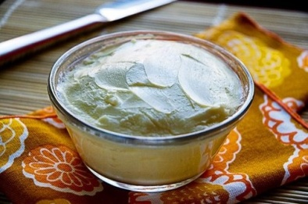
3. What conclusions do you draw about the effect of agitation on cream?
_____________________________________________________________________________________
_____________________________________________________________________________________
_____________________________________________________________________________________
4. Would the results of this experiment have been the same if you had agitated milk? Explain.
_____________________________________________________________________________________
_____________________________________________________________________________________
_____________________________________________________________________________________

