Child Care Guidance Unit 2:
EMPLOYMENT SKILLS: Name:___________________________
Job Application Interview & Work Skills
Rights and Responsibilities of Child Care Employees
Employee Rights | Employee Responsibilities
- Quality workplace  - ____________________________  - Employee Benefits  - Job _________________________  - Supportive Supervision  - Environment free from discrimination  and sexual harassment  - ____________ work environment. | - Do your _____________________________.  - Comply with all ____________________ and  state childcare licensing requirements.  - Adhere to ___________________ standards.  - Provide appropriate, ______________ care.  - Good attendance /be __________________.  - Professional appearance.  - ____________________________________.  - Maintain ____________________________.  - _________________________when needed.
When Seeking a Job:
- Check with ________________________, friends, relatives, _______________________,
internet and _____________________________ for job openings.
- Obtain applications, complete and return to businesses.
- Mail _____________________________with _________________ when applying for jobs outside your community.
- ALWAYS be _____________________________ and likeable.
JOB APPLICATION
- Fill out the application form ____________________ and ______________________.
- Use a ___________ and write _____________________.
INFORMATION may be collected from:
- Birth Certificate -_____________________ -Driver’s License -______________________
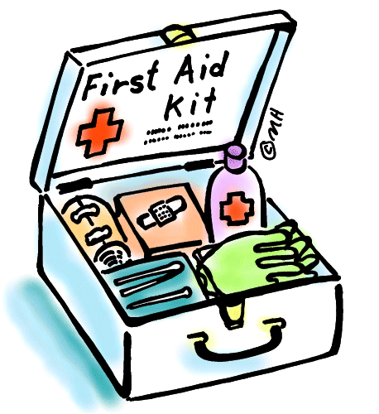
EMPLOYER MAY REQUIRE:
- Special Permits
  - Food Handlers
  - ________________________________
  - 1st Aid Training
  - ________________________________
- Blood Test
- _____________________________ for background check.
The INTERVIEW:
- ____________________________________
  - Arrive about 10 minutes early.
  - Find the location of the interview BEFORE the day of the interview.
- _______________________________ yourself and use a firm handshake.
  - Be Pleasant
  - In both _____________________ and ________________________ language
  - Be attentive, alert, ___________________________ and use eye contact.
- DO NOT chew Gum
Your DRESS and APPEARANCE | Does APPEARANCE MATTER …
- How you _____________ makes a statement before you even open your mouth!  - Appearance =  ________________________ | Clothing should be:  - ___________________________ being sought  - Clean and pressed  - ________________________  Personal Grooming Includes:  - Hair, Beards, Nails,  - Breath - Body Odor  Avoid: ________________ make up, perfume,  jewelry, or ____________________________.

QUALITIES EMPLOYERS ARE LOOKING FOR:
- Communication Skills (written & verbal)

- Honesty and __________________________

- Teamwork Skills - getting along with others

- ________________________________ Skills

- Strong _______________________________

- Motivation / __________________________

- Flexibility

- _______________________ Skills (Problem Solving)

- Computer Skills

- _______________________ Skills

You got the Job - NOW KEEP IT!
Find a Job you will ___________________!
- Be ON TIME - Don’t ______________ SICK LEAVE.
- Be a HARD WORKER-Get the Work DONE.
- Follow ________________!
- Keep a LEARNING ATTITUDE.
- Do Not ________________.
- HELP in any way possible.
- Work ___________ not __________________ other employees.

