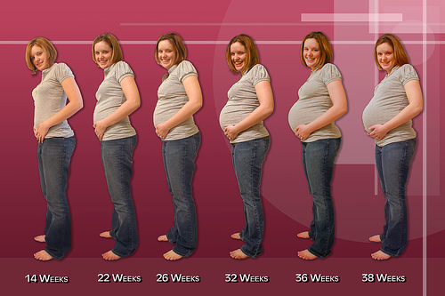
Early Signs of Pregnancy 2.2
Missed ________________________, Fullness or mild ache in lower abdomen or back,
Enlarged and ____________________________, Nausea or vomiting, _____________
___________________, and Fatigue. As pregnancy progresses you may experience:
_________________________ and Food cravings.
Types of Pregnancy Tests
Lab test ____________________________________ or a Home pregnancy test.
Pregnancy is _______________________________ from the first day of your last menstrual period (LMP) and normally lasts about _________________ from conception to the birth of a baby.
First Trimester: Early Changes in a Woman's Body 2.3
Weight gain of _________________________; Increase size in breasts and abdomen;
Hormone changes may cause _________________ (feeling irritable); Pressure on
bladder causes more frequent urination; _____________________________; and Extreme tiredness. If you have been pregnant before, you might feel differently this time around.
As your body changes, you might need to make ______________________________, such as going to bed earlier or eating frequent, small meals.
Fortunately, most of these _____________________________ as your pregnancy progresses. Some women might not feel any discomfort at all!
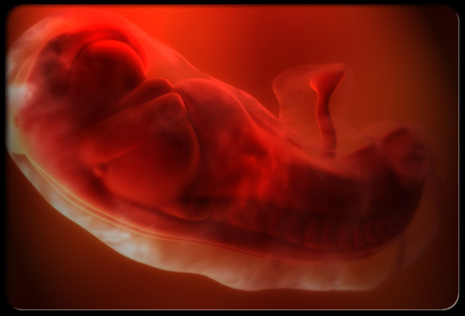
First Trimester: The Baby at 4 Weeks 2.7
The baby's ___________________________ have begun to
form, the _______________________, Arm and leg buds
appear, and the baby is now an ______________ and 1/25 of an inch long.

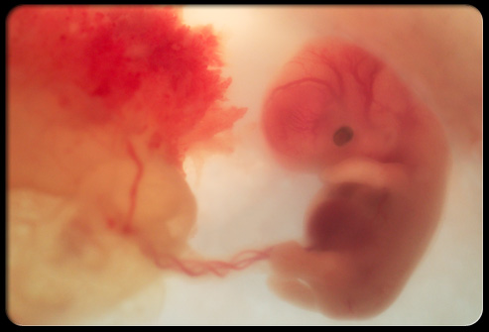
The Baby at 8 Weeks 2.7
- The baby is a ___________ and looks more like a human.
- Your baby is nearly ________________ and weighs less
than 1/8 of an ounce.
- All _______________________ and external body
structures have begun to form.
- The baby's heart beats with a ________________________________.
- The arms and legs grow longer, and fingers and toes have begun to form
- The ____________________________________________________.
- The eyes have moved forward on the face and eyelids have formed.
- The umbilical cord is clearly visible.
The Baby at 12 Weeks 2.7
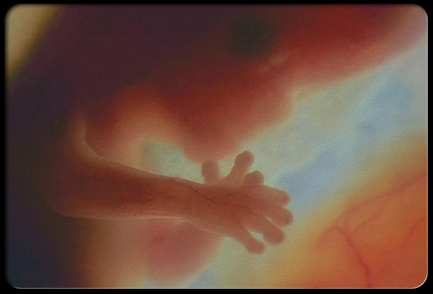
- Head growth has slowed, and your baby is much longer.
Now, at about ______________ long, your baby weighs
almost an ounce.
- The nerves and muscles begin to work together. The
baby _______________________________________.
- The external sex organs _________________________________________.
- A woman who has an ____________________ in the second trimester or later might be able to find out the baby's sex.
- ___________________ to protect the developing eyes. They will not open again until the 28th week.
Second Trimester: Changes a Woman May Experience 2.3
Feel the baby move – this is called __________________ and usually occurs during the
4th month and helps determine due date. Begin to wear ______________________ as they gain weight. For most women morning sickness is over by the 2nd Trimester, for
some it continues. Discomforts may include _____________, constipation, heartburn,
___________________, leg cramps, mood swings, dizziness – these ______________ but should be reported to the doctor.

As your body changes to make room for your growing baby, you may have:
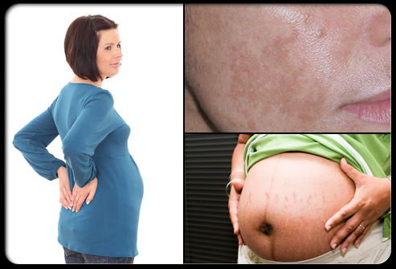
- Body aches, such as back, abdomen, groin, or thigh pain.
- ______________________ on your abdomen, breasts, thighs, or buttocks.
- Darkening of the skin around your nipples.
- A _________________________ running from belly button to pubic hairline.
- Patches of darker skin, usually over the cheeks, forehead, nose, or upper lip. Patches often match on both sides of the face. This is sometimes called the
____________________________.
- Numb or tingling hands, called carpal tunnel syndrome.
- ___________________________ on the abdomen, palms, and soles of the feet.
(Call your doctor if you have nausea, loss of appetite, vomiting, jaundice or fatigue combined with itching. These can be signs of a serious liver problem.)
- Swelling of the _____________________________, fingers, and face.
(If you notice any sudden or extreme swelling or if you gain a lot of weight really quickly, call your doctor right away. This could be a sign of preeclampsia.)
Second Trimester: The Baby at 16 Weeks 2.7
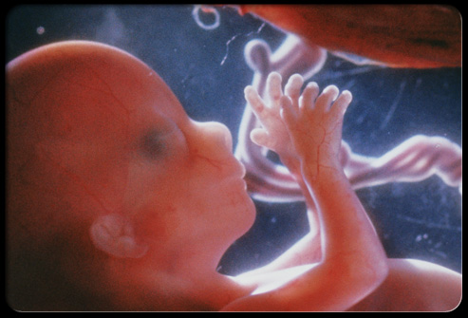
- The baby makes __________________ with the mouth
(sucking reflex).
- The baby reaches a length of about _________________
and weighs almost 3 ounces.
- Muscle tissue and bone continue to form, creating a ______________________.
- Skin begins to form. You can nearly see through it.
- ___________________ (mih-KOH-nee-uhm) develops in your baby's intestinal
tract. This will be your baby's first bowel movement.
The Baby at 20 Weeks 2.7
- The baby is more active. You might feel ________________________________.
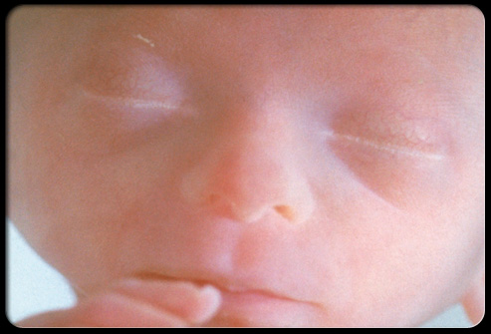
- The baby can ______________ and swallow.
- Now halfway through the pregnancy, the baby is about
____________________ and weighs about 9 ounces.
- The baby is covered by fine, downy _______________________ (luh-NOO-goh)
and a _________________________. This protects the forming skin underneath.
- Eyebrows, eyelashes, fingernails, and toenails have formed. The unexpected death of a developing baby before twenty weeks of pregnancy is called a
________________________ after 20 weeks it's called a __________________.
The Baby at 24 Weeks
- Is about 12 inches long and ________________________________________.
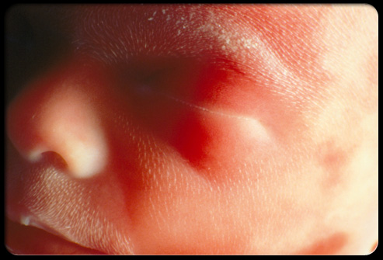
- Footprints and fingerprints have formed.
- Real _________________________ on your baby's head.
- Bone marrow begins to make ______________________.
- Taste buds form on your baby's tongue.
- The lungs are formed, but do not work.
- The hand and ________________________ develop.
- Your baby sleeps and wakes regularly.
- If your baby is a boy, his testicles begin to move from the abdomen into the scrotum.
- If your baby is a girl, her uterus and ovaries are in place, and _______________
_______________________ have formed in the ovaries.

Third Trimester: Changes a Woman May Experience 2.3
- Physical discomforts: heart burn, ______________________, varicose veins, swollen ankles, muscle cramps in the legs, lower back pain.
- Tender breasts, which may leak ___________________________________.
- Belly button may stick out.
- May have _______________________________.
- May experience ____________________________ due to the top of the uterus pushing against the diaphragm.
- Most women experience _______________________ as delivery approaches –
______________________ lower in the abdomen. Breathing becomes easier, but pressure on bladder increases.
- ___________________________, which can be a sign of real or false labor

Changes as the Due Date Approaches
- Get excited — the final countdown has begun!
- As the due date nears, ________________________________ and softer
______________________. This is a normal, natural process that helps the birth
canal (vagina) _________________________ during the birthing process.
- Your doctor will check your progress with a _______________________ as you near your due date.
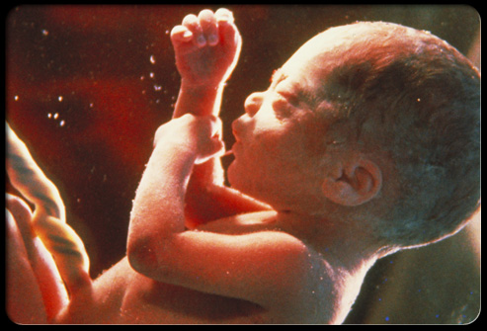
Third Trimester: The Baby at 32 Weeks

- The baby is gaining weight quickly, _______________
________________. Now, the baby is about 15 to 17
inches long and weighs about 4 to 4½ pounds.
- The baby's _______________________________, but still soft.
- Your baby's kicks and jabs are forceful.
- The ______________________________ and sense changes in light.
- Lungs are not fully formed, but practice "breathing" movements occur.
- Your baby's body ___________________________ vital minerals, such as
____________________________.
- Lanugo begins to fall off.
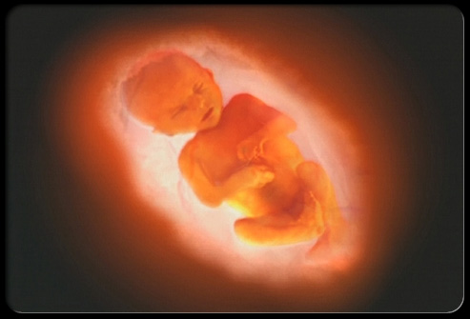
The Baby at 36 Weeks
- The baby is about _______________________ and
weighs about 6 to 6½ pounds.
- The protective ______________________________
get thicker.
- ________________________ increases. Your baby is getting bigger and bigger and has less space to move around.
- Movements are ____________________, but you will feel stretches and wiggles.

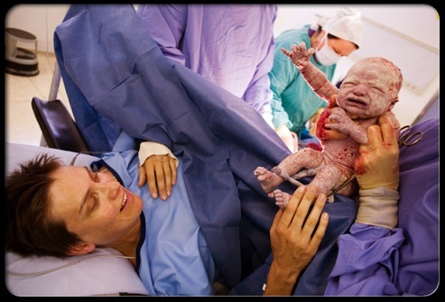
The Baby at 37 to 40 Weeks
- By the end of 37 weeks, the baby is ____________
_____________________.
- The baby's organs are ready to function on their own.
- As the due date nears, the baby may _____________________________ for birth. Most babies "present" head down.
- At birth, the baby may weigh somewhere between ___________________
_______________________________ and be 19 to 21 inches long. Most full-term babies fall within these ranges.
- But healthy babies come in many different sizes.

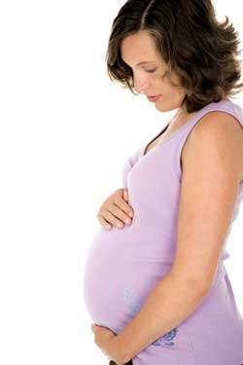
Possible Pregnancy Complications 2.4
Vaginal bleeding, ______________________, Excessive thirst, Reduced or _________
________________, Severe abdominal pain, Persistent ________________, Severe
vomiting, Fever, __________________ of the face, hands, or ankles, Blurred vision or
dizziness, Prolonged ____________________, and Increased vaginal mucus.
Pregnancy Complications
____________________________ is a type of ________________________; also called toxemia or pregnancy induced hypertension. (If you notice any sudden or extreme swelling or if you gain a lot of weight really quickly, call your doctor right away. This could be a sign of
preeclampsia.)
_____________________________ is a type of diabetes that usually disappears
following delivery. It is diagnosed with a __________________________.
Prenatal Tests 2.5
- Can detect more than 100 kinds of _____________________________.
- Can help determine if the baby needs special _________________________ before or after birth.
Types of Tests:
- ____________________ (sonogram) - wand rubbed across the abdomen.
- __________________________ (CVS) is done during the _________________
________________________. Fragments of the placenta are removed from the uterus and tested to detect certain disorders such as cystic fibrosis and down syndrome.
- __________________________ - is done between the ____________________
______________________. Amniotic fluid is drawn from the mothers’ abdomen. Usually done with mothers over the age of 35 who have a higher incidence of babies born with Down syndrome. It tests for hundreds of genetic and chromosomal disorders and carries a slight risk of infection that could lead to miscarriage.
STDs can Harm the Fetus 2.6
- Genital herpes – may cause ________________________ or mental retardation.
- Syphilis – can cause severe damage to the fetus, or ______________________.
- Gonorrhea – can cause _______________________ that can turn into more serious infections.
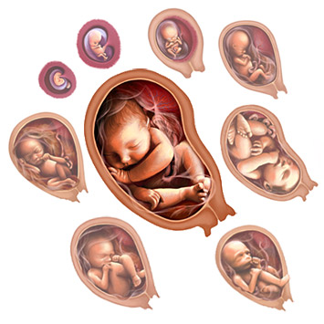
- HIV – the virus that leads to AIDS, can be transmitted to the fetus by HIV-positive mothers.
Stages of Development 2.7
- The 1st stage is the Period of the Zygote or fertilized egg. This union is called _____________________.
_____________________________________________________________ and implants itself to the lining of the uterus and begins to grow. The zygote grows by cell division. This stage lasts from conception to _________________________.
Gender Determination
The single celled zygote contains all the genetic information needed to determine the gender of the developing baby.
Each person possesses __________________________________________: one is inherited from the father and one from the mother.
_____________________________________________ (Ovum or Egg)
_____________________________________________ (Sperm)
__________________________ is determined _________________________!
- Embryo (2nd Stage) – starts when the zygote is __________________________. During this stage all major body systems begin to develop. This stage lasts about __________________________.
- Fetus (3rd Stage) – it is the final stage. It starts at the end of the 2nd month and lasts ______________________. The embryo starts out about the size of a walnut and increases 50 times in size.
Reduce Stress during Pregnancy 2.8
- __________________________________ in your life
- Look for ways to _______________________________ on those stressors.
- Eliminate unnecessary responsibilities.
- Take a nap, write in a journal, or listen to music.
Avoid Teratogens – _________________________________________________.
Alcohol, Drugs, Infections (Rubella), Smoking, Harmful fumes, Paint products, Lead, and X-Rays.
- Women who have 4 or more drinks a day run a high risk of having a
baby with _________________________________.
- FAS is the leading cause of mental retardation and occurs __________________
____________________births.
- Premature births and low birth weight are ____________________________ by the mother.
- Smoking reduces the ___________________________ the fetus receives.
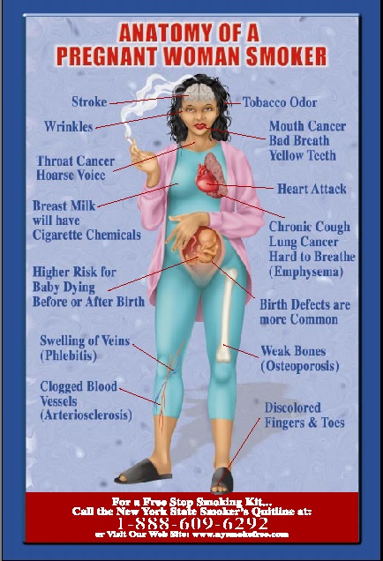
- Tremendous harm can come to a baby whose mother has used crack, cocaine,
heroin, LSD, or other ______________________________.
- The newborn may be ___________________________ and is at risk for a stroke, brain damage, and even death.
- _____________________________ and premature birth are likely.
- Many of these children face a lifetime of ________________________________.
- Marijuana ________________________________ and can put the fetus at risk.
- There have been some reports of children born with characteristics that are
_________________________________.
- If an expectant mother has used drugs during pregnancy, she must
_________________________ with her physician.
Caffeine is not considered a teratogen but it may cause:
__________________________, Reduces absorption of fluids and calcium
needed by mother and baby, ____________________________, and severe
mood swings.
Types of health care for the mother and baby: 2.9
- Obstetricians – doctors who _________________________________.
- Gynecologists –doctor who specializes in the health of the _________ _________________________.
- Family practice physicians’ ____________________________.
- Certified nurse – midwife is a nurse trained to care for women with low-
_____________________________ and to deliver their babies.
Prenatal Care Is Very Important Throughout Pregnancy 2.9.1
During the first exam the doctor will ask:
_________________________ of both spouses, menstrual history,
____________________, Diseases or __________________________, if either spouse smokes, drinks or has a sexually transmitted disease.
You will also: ___________________, have your blood pressure taken, have blood
drawn to ___________________________, __________________, have a pap smear, and check for immunity to rubella or German measles.
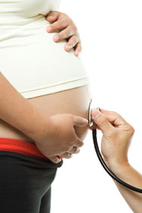
Typical Schedule for Checkups
___________________ until 7th month
More frequently to _______________________
Weekly visits during the 9th month
Eating a balanced diet is important during pregnancy:
- For ________________________________ of the fetus
- Can __________________________________ of the mother during pregnancy
Note: follow the food guide pyramid adding one glass of milk and one extra
serving of leafy green vegetables.
- It’s important to get _________________________ and exercise when pregnant.
- Wear _____________________________________.

Teen Pregnancy Risks 2.10
- Problems with spine and ___________________________ during pregnancy and birth
- Difficulty delivering a full term baby
- An ______________________ increases the risk of low birth weight.
- More likely to experience ___________________________
- Pregnancy-induced hypertension
- Miscarriage and __________________________ are higher
- Death rate from complications of pregnancy is much higher for teens under age fifteen
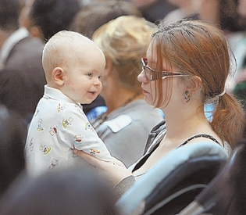
Cost of Teen Pregnancies to Society 2.11
Annual cost of about $34 billion
The money:
- Supports ________________________ who cannot take care of themselves
- Provides ______________________ for abused children
- Provides ___________________________ for children with disabilities
Careers related to Pregnancy and Prenatal Development 2.12
- Obstetricians and Gynecologists OB/GYN
- Family Practice Physicians
- Certified Nurse/Midwife

- ________________________________ (also called Maternal-fetal specialists)
_______________________________________________________________.
- Obstetric and Neonatal Nurses
Birth Plans will involve Decisions Concerning: 2.9.3
- Medication
- ________________________________
- Who can be present during labor and delivery
- ________________________________
- Feeding the infant
- ________________________________

