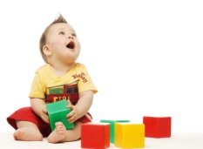

|  |  |
| --- | --- |
| **5 Areas of Development** | **Definitions of Development** |
| 1) | a developmental process that refers to the physical growth of a person's body. This growth affects ______________, weight, and _________________ body systems. |
| 2) Emotional | a development process that refers to the ability to experience,   _________________, and _____________________ emotions. |
| 3) | a developmental process that refers to the way people ___________   to _____________ around them. |
| 4) Intellectual | a developmental process that refers to the growth of the brain and   the ______ of ___________ skills. |
| 5) | a developmental process that refers to the ability to know _________   from __________________. |

**Child Development** is the study of _________________________________________________.

**Benefits of Studying Children:**

- Learn why children _________, ___________, and _______ the way they do.

- Discover caregiver’s _____________________. - Enjoy children more.

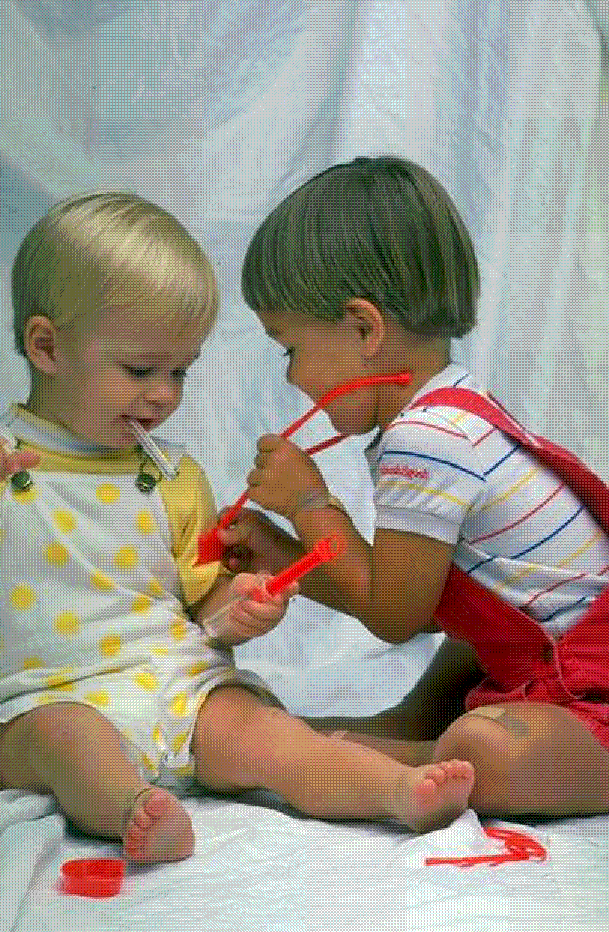 - Learn about _____________ opportunities.

**Childhood is known to be:**

* A period of _____________________________________________.
* A time of ___________________________________ on caregivers.
* _____________________________ for adult life.

**Childhood Past and Present**

|  |  |  |
| --- | --- | --- |
|  | **Past** | **Present** |
| **Health** |  |  |
| **Education** |  |  |
| **Work** |  |  |
| **Play** |  |  |
| **Dress** |  |  |

|  |  |
| --- | --- |
| **Toys children play with have changed dramatically over time. Do you think children learn more by playing with today’s toys? Explain?** | **If you were a parent, which of the toys in the photo would you prefer your child play with? Which toy do you think children would prefer? Why?** |
|  |  |

**Brain Development**

* The brain develops __________________________________________ that allow it to think & control the body in certain ways.
* These connections can be encouraged by __________________________________ and   
    
  _____________________ (any activity that arouses a baby’s sense of sight, sound, touch, taste, and smell).
* Babies who receive stimulation __________________________________________ and have a more secure self-image.

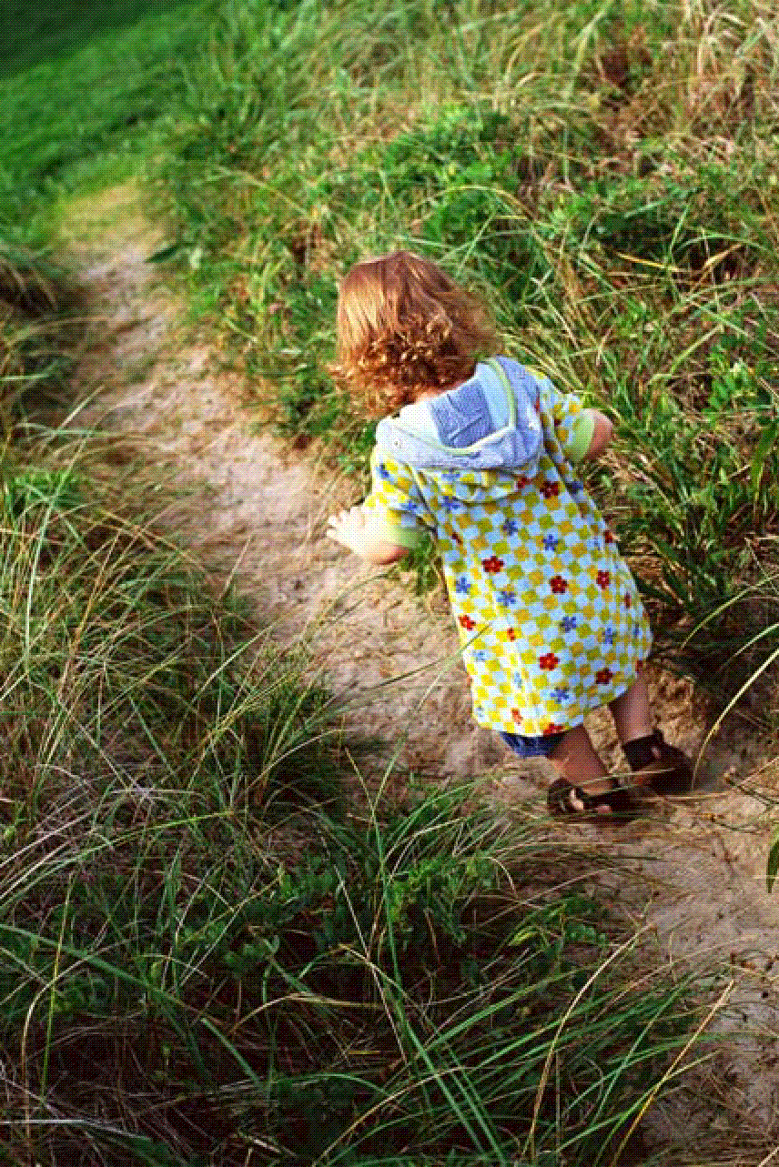**Development follows five patterns (**Characteristics of Development):

* Development is ____________________________________.
* It builds on earlier learning.
* Proceeds at _______________________________________.
* Different areas are interrelated.
* Development _________________________ throughout life.

**Influences of Heredity & Environment**

* __________________ provides the _________________________________________.
* Passing on of certain characteristics from earlier generations.
* ________________________ is the people, places, and things that surround and influence a person.
* Inherited traits can be ______________________________________________ by what happens to a child in life.

Read Page 17 The Role of Self Esteem in Development. Write one sentence stating the conclusions the author draws.

_____________________________________________________________________________  
  
_____________________________________________________________________________  
  
_____________________________________________________________________________

|  |
| --- |
| **Ways to Help Children Develop Self-Esteem:** |
| * Give __________________________. * Do not be ______________________. * Set ___________________________.   **The Individual  Life Cycle**   * ___________________ new activities. * _____________________ self-esteem. * Be ________________ about mistakes. |

**Developmental Tasks: Summarize each of the developmental tasks.**

|  |  |
| --- | --- |
| **Adolescence** |  |
| **Young Adulthood** |  |
| **The Thirties** |  |
| **Middle Age** |  |
| **Late Adulthood** |  |
| **Very Late Adulthood** |  |

**Why We Observe Children:**

* To see their _________________________ personality.
* To see how one stage leads to the next and ___________________________________.
* To adapt activities to meet the child’s _______________________.
* To identify children who have special needs or _______________________________.

___________________ – uses personal feelings and opinions rather than facts.  
  
 ___________________ – uses just the facts! What the observer saw and heard …nothing more!

* **Record only the ___________________________.**
* **Record the facts in the ____________________________________.**
* **Describe appearance and actions in __________________, vivid detail.**
* **Record every detail without omitting anything.**
* **Record _____________________________________________.**
* **Do not interpret as you observe.**
* **Do not record anything _______________________________________.**
* **Use words that describe but do not judge or ______________________.**

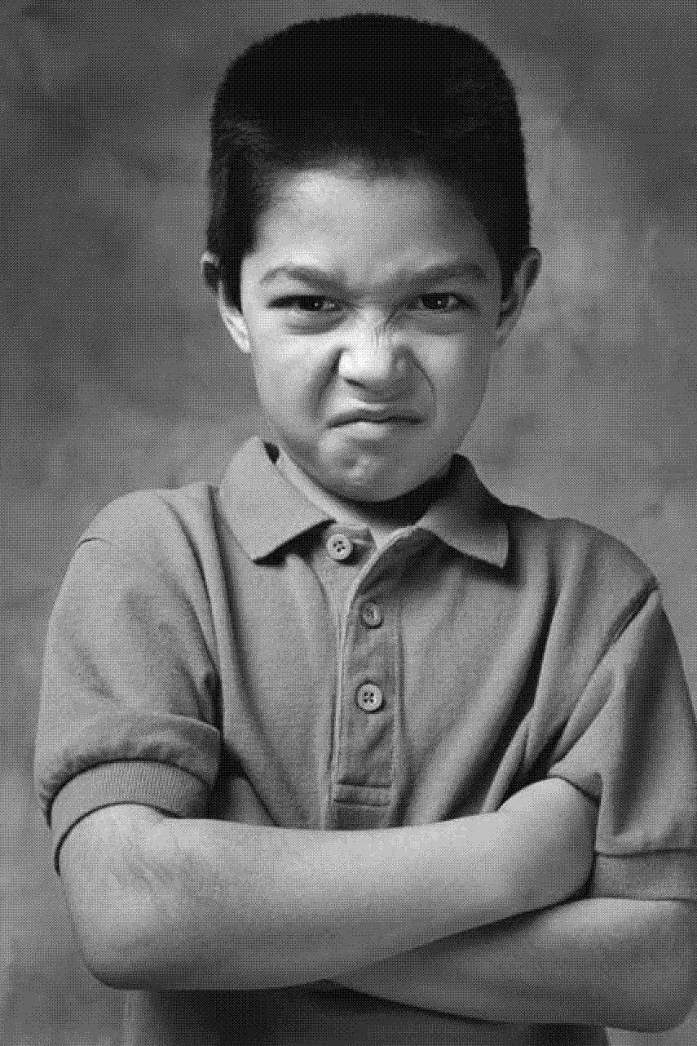

|  |  |
| --- | --- |
| **Types of Observation Records** | |
| **Running Record** |  |
| **MCj02504120000[1]Anecdotal Record** |  |
| **Frequency Count** |  |
| **Developmental Checklist** |  |

**How to Interpret Observations:**

* The _______________ an observer forms and expresses about what was observed is   
    
  called an ______________________________.
* Anyone who observes children must maintain __________________________ to protect privacy.
* Observations are usually short and for this reason your interpretation may not be   
  _____________________.

**Careers that involve working with children:**

* Child care professional
* _______________________
* Aide
* _______________________
* Social worker
* _______________________