|  |  |
| --- | --- |
| **What factors influence your eating habits?** |  |

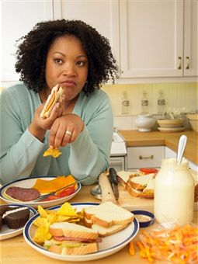Reasons we eat include: (List examples)

Physiological: ____________________________________________________

Psychological: ____________________________________________________

Cultural: ________________________________________________________

Social: __________________________________________________________

Environmental: _________________________________________________________________

**List the first thing that comes to your mind when I call out a food.**

1)__________________  
  
2)__________________  
  
3)__________________  
  
4)__________________  
  
5)__________________  
  
6)__________________  
  
7)__________________  
  
8)__________________  
  
9)__________________  
  
10)__________________  
  
11)__________________  
  
12)__________________

What did you learn from the Taste bud and Fear Factor Experiments?  
  
 ___________________________________________________  
  
 ___________________________________________________  
   
 ___________________________________________________  
  
 ___________________________________________________

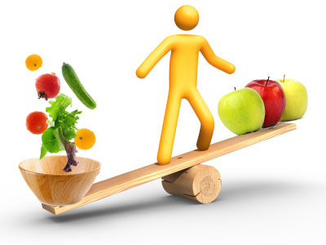 **How can you maintain a healthy, balanced diet to   
 reduce the risk of health problems throughout your   
 life span?**

Food provides __________________ needed:

To give you ____________; for growth, maintenance, and repair of the body;  
  
 and to keep the ___________ _______________ working properly.

Nutrients ______ _______________ to keep your body healthy. It's important   
  
 to eat a _____________ of foods in order to get the nutrients you need.

Use the "Guide to Good Food” textbook to research various nutrients. List the nutrients function(s) and food sources in the chart. Then answer the questions that follow. Complete workbook page 13 "Nutrient Deficiencies and Excesses.

|  |  |  |
| --- | --- | --- |
| **Nutrient** | **Function** | **Food Sources** |
| **Carbohydrates** |  | Simple Carbohydrates:  Complex Carbohydrates: |
| **Fats** |  |  |
| **Proteins** |  |  |
| **Vitamins** | **Fat-Soluble** |  |
| Vitamin A |  |  |
| Vitamin D |  |  |
| Vitamin E |  |  |
| Vitamin K |  |  |
| **Vitamins** | **Water-Soluble** |  |
| Vitamin C |  |  |
| Folate |  |  |
| Thiamin |  |  |
| Niacin |  |  |
| Vitamin B12 |  |  |
| **Minerals** |  |  |
| Calcium |  |  |
| Sodium |  |  |
| Iodine |  |  |
| **Water** |  |  |

Do you regularly eat sources of each of the nutrients listed in this chart? __________________________

If you answered no to the above question, which nutrients are lacking in you diet? __________________

_____________________________________________________________________________

Why is it necessary to include sources of each of these nutrients in your diet? ______________

______________________________________________________________________________

______________________________________________________________________________

How would you define good nutrition? ______________________________________________

______________________________________________________________________________

**Complete Proteins**

Proteins are made up of chemical compounds called ________________ _______________.   
There are 20 different amino acids. The body can manufacture all but 9 of these. They are called   
  
____________________ _____________ __________, which you must get from the food you eat.

_____________________ foods and ______________________ have complete proteins.

**Incomplete Proteins**

Lack one or more essential amino acids. Foods from ____________ ______________ supply   
  
incomplete proteins. ________ ___________ or peas that are eaten with any ______________   
  
product, nuts, or seeds ______________ ______ _________ _____ will generally provide all of the essential amino acids**.**

|  |  |
| --- | --- |
| **_______ calories** | **sedentary (inactive) women and some older adults.** |
| **_______ calories** | **most children, teenage girls, active women, and sedentary men. Pregnant or breast feeding women may need more.** |
| **_______ calories** | **teenage boys, active men, and some very active women.** |

**U.S. Dept. of Agriculture suggested calorie intake**

**Recommend daily calorie intake:**

**_____________ from fat**

**_____________ from carbohydrates**

**____________ from protein**

**Fats**

|  |  |
| --- | --- |
| **Fats** | **calories per gram** |
| **Protein** | **calories per gram** |
| **Carbohydrates** | **calories per gram** |

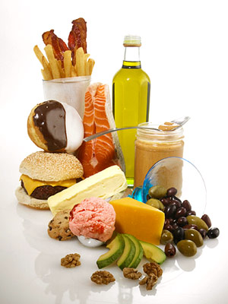Fat provides more than __________ as many calories per gram as carbohydrates and proteins. Experts recommend no more than ____________________ of your daily calories should come from fat.

No more than 10% should come from __________________________ fat.

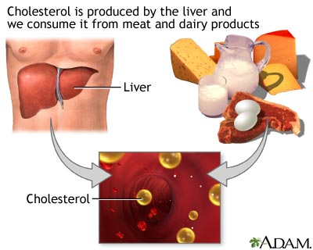**Limit** **Excess Fats and Cholesterol**   
Saturated fats, dietary cholesterol and trans fat can __________ blood cholesterol which is a risk factor for heart disease. Limit your daily cholesterol intake to __________________.

________ ______ ________ have also been linked to increased risk of several types of ___________.

**Digestion and Absorption**

Before nutrients in food can be used by the body it must go through the digestive process.

Digestion begins in the ______________ where _________________ begins to break down starches and makes food easier to swallow.

After foods have been broken down in the digestive tract, the body __________________ ________ _____________________.

The nutrients are then ________________________ in the cells to release energy or make other compounds needed by the body. Complete Workbook page 16 "How the Body Uses Food".

**Effect of Nutrition on Health and Body Mass**

BMI, or ____________ _____________ ____________________, is a number that correlates a person's height and weight.

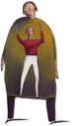

|  |  |
| --- | --- |
|  | **BMI** |
| Underweight |  |
| Overweight |  |
| Obese |  |

Health risks increase steeply in individuals with a BMI of 25+.

_________________________ predisposes one to higher risks of heart attacks, severe strokes, gallstones, certain cancers and a low body image.

**Each stage of the life cycle has different nutritional needs**:

**Lactating Women Pregnant and**

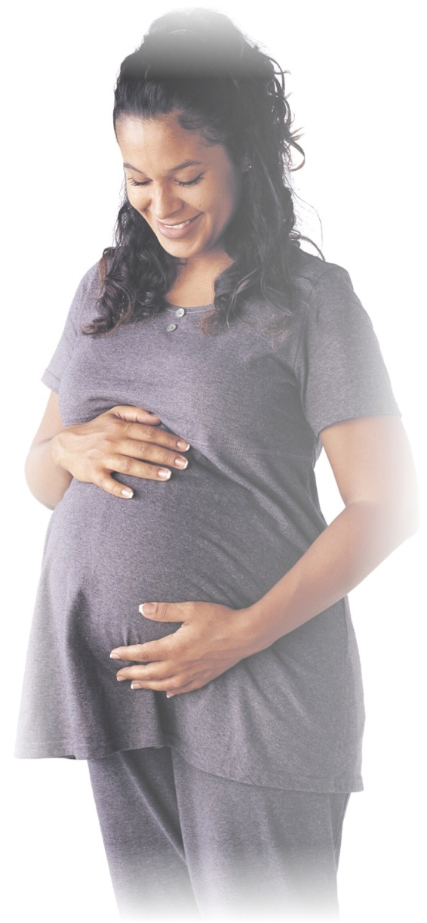

Follow the Choose My Plate recommendations. _______________ is needed during the first 3 months of pregnancy to   
  
help prevent ______________ ____________ _______________ in the fetus (RDA is 600 micrograms). Protein,   
  
calcium, and iron are needed to support the _______________ of the fetus, for the formation of bones and teeth, and to   
  
help the baby ___________ _____ _________ reserves. Pregnant women are often prescribed Prenatal vitamins and   
  
 should gain between ______________________.   
  
**Infants’** nutrient requirements are ________________ per unit of body weight than an adult. Infant’s have no nutrient   
  
reserves with the exception of ____________ which should last for the first _____________ of life. Growth is faster the first year   
  
of life than any other time (weight usually triples and length is usually 1½ times the birth length). ­­­­____________ _________  
  
are usually introduced between four and six months of age. The first solid food is usually a ____________ __________, iron fortified infant cereal.

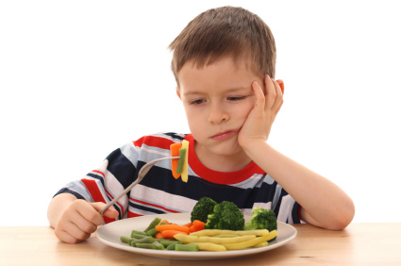**Preschoolers** have _________________________ eating habits. Can be influenced by family members’ likes and dislikes.  
Daily diet should meet their ____________________ _______________. Should _________ _____ ____________ to eat.  
Tend to like:

- _____________ _____________ foods - soft and lukewarm foods

- _____________ _____________ - bright colored foods

- _____________ _____________

**Parents can promote healthy attitudes about good nutrition by:** Setting a good __________________,

Encourage children to try __________ ________________, Get children ___________________ in food preparation, and

Refrain from using food as punishment. **Parents can help address children’s weight problems by:**Providing ______________ _____________, Discourage snacking in front of the T.V., and Providing ______________  
  
___________________. **Teens** have trouble meeting their daily nutrient needs because they frequently:  
  
**__________ ___________,** Eat junk food, and _______ _______ ______________________ __________.

**Energy needs** decrease as people become older due to _________________ _______________,   
  
difficulty in shopping, and __________________________.

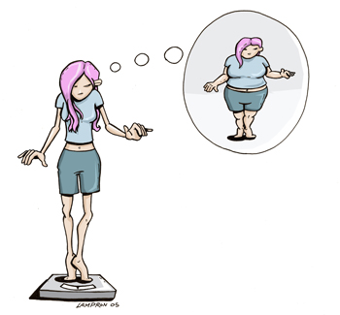People sometimes go on **Special Diets:**Vegetarian (_____________) diets do not include meat or animal byproducts. Lacto-ovo vegetarians include   
  
_______________ ___________________ and ________ in their diets. Medical diets for specific   
  
_____________ _________________ such as diabetes, heart disease, cancer, etc. and Weight Reduction diets.

**Underweight may be caused by:**

__________________, Inability to buy sufficient food or the right kind of

food, Lack of nutrition ________________________, Excessive activity level,  
  
 _____________ _______________________, Hyperthyroidism and cancer  
  
increases the metabolic rate and energy needs or, ___________________________ or emotional stress

**Tips to Gain Weight:** ________ ____________ _______________ (you can gain 2 lbs per week   
  
eating an extra 1000 calories per day).__________________ ______________ _________ and add a

second helping.Recognize and eat some high calorie foods. Eat high-calorie, nutritious snack foods.

_________ ________________ _________________ and whole-milk products.

**Causes and Effects of Obesity:** ________________ __________________ plays a role.

Age increases the risk. _________________ -Women have a tendency for weight gain.

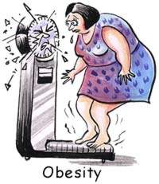Basal metabolic rate (Calories used at rest)._____________________ ____________________

Food preferences, _________________________

Medication, Environment and Psychological factors (watch out for comfort foods). **Physical Symptoms of Obesity may Include:**

- Shortness of breath -______________ ___________ -Swollen Ankles

- _____________ ___________________ like heart disease, stroke, diabetes, certain types of cancer,   
 gout, gallbladder disease.   
  
-________________ _________________ -Osteoarthritis -_______________________.

**Tips to Lose Weight:**

Select a variety of _____________________ _______________ ________________

Reduce high fat and sugary foods

Use low fat and ___________ _____________ ________________

Reduce food portions

_________________________________________________________________________________ :

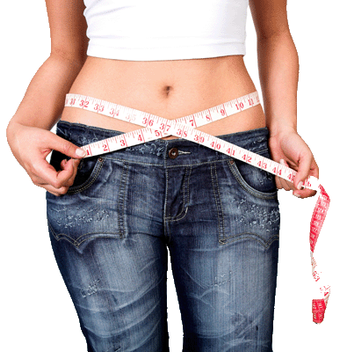 - Cook foods with little or no fat

- Avoid fried foods

- Trim fat from meals

- Broil or roast on a rack

- Stir-fry in small amount of vegetable oil

- Steam, bake, or boil vegetables

- Eat low-calorie foods

Eat ___________ _______________ ____________________ rather than three large meals.

**Exercise**

* _______________ _____________________________ and helps you burn calories.
* ______________ ____________________________ and keeps your skin healthy.
* Reduces your risk of heart disease, stroke, and colon disorders.

Athletes have an increased need for ____________ and ______________________.

**Factors in lifestyle that affect nutrition and health:**   
  
- _____________________________ - Overeating

- Drug and alcohol abuse - _________________ ________________

- __________________________ - Rest

- ________ (fat, cholesterol, salt, sugar, fiber) - Dieting for weight loss

- Religion