Many scientist work as quality control specialists, which means they test foods sold by grocery stores and restaurants to make sure they are safe and taste good. To do this, these scientists must first explore their own sense of taste. Complete the following experiments to get a better understanding of how you taste.
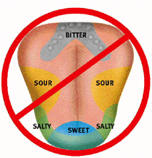
Where are your Taste Buds?
Our tongues contain little bumps we call taste buds. There are four different kinds of taste buds: Sweet, Sour, Salty, and Bitter. All other tastes come from a combination of these four basic tastes. Scientists once thought that the four kinds of taste buds were in separate places on our tongue: salty taste buds on the side, bitter taste buds on the back, etc. More recent studies suggest that our taste buds are not located exactly this way, and that different parts of the tongue can detect all types of tastes. Umami (oo-Mom-mee), or savory, is a fifth basic taste that has been discovered. Can you map where your taste buds are located?
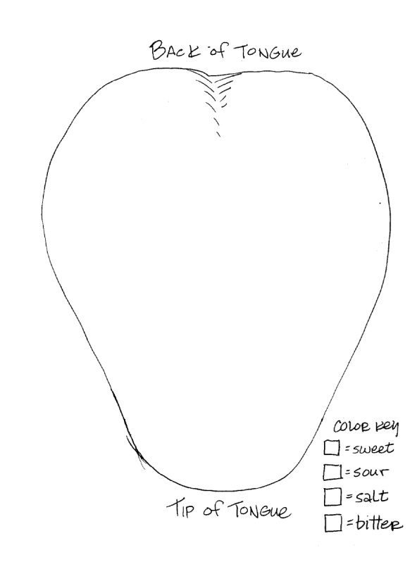
Materials needed: Four beakers, cotton-tipped swabs, sugar, salt, four different colored crayons, vinegar, lemon or lime juice, and strong coffee or tonic water.
Step 1: Fill the beakers about 1/2 full with water. Label them "salty", "sweet", and "sour".
Step 2: Mix sugar into the beaker labeled "sweet", salt into the beaker labeled "salty", vinegar, lemon, or lime into the beaker labeled "sour".
Step 3: Label the last beaker "bitter" and add coffee, grapefruit juice or tonic water.
Step 4: Dip a cotton-swab into one of the solutions and touch the swab to different parts of your tongue. Using crayons, record on the tongue, where you taste each solution. Make sure that you write down what taste each color represents.
Step 5: Rinse out your mouth with water before starting with the next taste.
Step 6: Repeat the procedure with all of the tastes using a clean cotton-swab with each.
Fear Factor Challenge
The challenge is to get beyond the “good” and the “nasty”, and really articulate the many elements, like texture, smell, and appearance, that influence how we experience new foods when we can’t easily identify them as familiar dishes.
After tasting the mystery foods, record your immediate reaction to the food and describe what you think it is. After the taste tests, compare your reactions with your group members then find out what the actual food or drink item was.
Identify Food Describe Taste/Texture Like Dislike

