You have two class periods to create 5 types of media that will
Promote FCCLA.

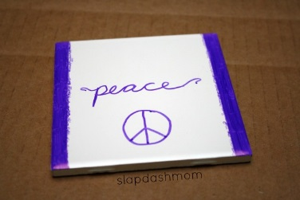
You can use any materials on the supply table, the cricut machine, poster board, construction paper etc. Ask if you need something else and I will see if I have it.

- Coaster: Get a white tile from the supply table and decorate using sharpies. Bake for 15 minutes at 350. Add felt to the back, with hot glue.

- Door Hanger: Create and decorate a door hanger using materials on the supply table. Be creative!

- Coffee Wrap: Use the pattern provided and the corrugated cardboard to create and decorate a coffee wrap.

- Bookmark: Create a bookmark using a Microsoft program or template. Email to Mrs. Hubbell to print on white cardstock.

- Bumper sticker: Create and decorate a bumper sticker with a catchy phrase to promote FCCLA.

