Name_______________________________
Date _______________
Leadership & Service Learning Unit 2

Standard 2.0 actively participate in leadership and service learning (FCCLA – Family, Career and Community Leaders of America)
Creed, Motto, FCCLA, Purposes, Critical Thinking, National Programs, Acronym, Emblem, Mission

1. _________________________________________ - a statement of belief.
2. _________________________________________ – a statement that defines an organization’s overreaching
purpose.

3. _________________________________________ – a word or saying that expresses ones aims, ideals or
guiding rule.
4. _________________________________________ – the object for which something exists or is done.

5. _________________________________________ - a word formed from the initial letters of a phrase or title.

6. _________________________________________ - an organization for students who are enrolled or have
been enrolled in family and consumer sciences classes for
at least one semester.

7. _________________________________________ - frameworks for FCCLA action that encourage members to
enhance their personal growth and build their leadership
skills.
8. _________________________________________ - a visual symbol that represents a group.

9. _________________________________________ -reflecting or thinking about complex issues, usually to
make a decision or action.
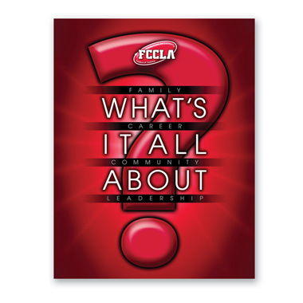

FCCLA Creed
We are the Family, Career and Community Leaders of America. We face the future with warm courage and high hope. For we have the clear consciousness of seeking old and precious values. For we are the builders of homes, homes for America's future, homes where living will be the expression of everything that is good and fair, homes where truth and love and security and faith will be realities, not dreams. We are the Family, Career and Community Leaders of America. We face the future with warm courage and high hope.

2.1.1: Examine reasons for belonging to FCCLA
Work in groups to compile a list of reasons for belonging to FCCLA:

Research and complete the FCCLA Webquest by going to www.fcclainc.org
Performance Indicator 2.1 Investigate FCCLA as a leadership and service learning organization
2.1.2: State requirements for active membership in FCCLA

Performance Indicator 2.2: Describe the important fundamentals that FCCLA encompasses
2.2.1: Describe significant events of FCCLA history
2.2.2: Describe significant symbols in FCCLA
2.2.3 Explain the meaning of the mission, creed, and the motto of FCCLA
2.2.4 Explain the 8 purposes of FCCLA

Research using state and national FCCLA websites
2.1.3 Develop a plan for recruitment, retention, and recognition

Create 5 types of media to promote FCCLA Recruitment using material provided. We will choose 1st, 2nd, and 3rd place overall winners!

Create a poster detailing National Programs in FCCLA
2.2.5 Relate FCCLA National Programs to relevant service learning projects
- Career Connection
- Financial Fitness
- Power of One
- Student Body

- Families First
- Leadership Service in Action
- Stop the Violence
- FACTS

