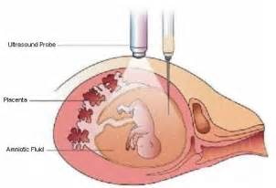
Go to www.babycenter.com to find the following information.
List 7 things an ultrasound will provide:
- _________________________________________________________________________

- _________________________________________________________________________

- _________________________________________________________________________

- _________________________________________________________________________

- _________________________________________________________________________

- _________________________________________________________________________

- _________________________________________________________________________

- Explain an ectopic pregnancy: ________________________________________________

_________________________________________________________________________

_________________________________________________________________________
- How often does it occur? ____________________________________________________
- What are your options? _____________________________________________________
- Explain Rh sensitization: ____________________________________________________
_________________________________________________________________________
_________________________________________________________________________
- How can you avoid becoming RH-sensitized? ____________________________________
_________________________________________________________________________
_________________________________________________________________________
Name 3 chromosomal abnormalities that can be detected from CVS testing and describe the defect.
Chromosomal Defect Description of Defect
13.

14.

15.

16. What is the most common reason to have an amniocentesis? _____________________
__________________________________________________________________________
Explain 3 other reasons amniocentesis may be done:
17. _______________________________________________________________________
18. _______________________________________________________________________
19. _______________________________________________________________________

