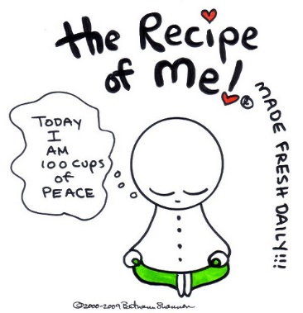
Instructions: You will be making a recipe of yourself to help me and the class get to know you better. Your recipe must have 8 ingredients (traits), and must have a least one ingredient (trait) from each of the following categories:
- Physical descriptor - Personality trait
- Culture, Religion or Heritage - Interests
- Something that is important to you

- ____________________________________ 5. ____________________________________
- ____________________________________ 6. ____________________________________
- ____________________________________ 7. ____________________________________
- ____________________________________ 8. ____________________________________

List of Ingredients:
Directions: Be creative and use equipment and cooking terms in your directions. Keep it clean!
______________________________________________________________________________________
______________________________________________________________________________________
______________________________________________________________________________________
______________________________________________________________________________________
______________________________________________________________________________________
______________________________________________________________________________________
______________________________________________________________________________________
______________________________________________________________________________________
______________________________________________________________________________________
______________________________________________________________________________________
______________________________________________________________________________________

