*MC900412684[1]* Name: ___________________________________

Period: __________ Date: __________________

**Star Polisher**

*My job is to take the stars in and shine them and buff them and then send them out into the sky.*

*-Leah Becks*

I have a great job in the universe of occupations. What do I do? I am a “Star Polisher.”

It is a very important job. If you want to know how important, just go out at night and look at the stars twinkling and sparkling.

You see, I am a teacher. The stars are the children in my class. My job is to take them in-in whatever shape they come – and shine and buff them and then send them out to take their places as bright little twinkling beacons in the sky.

They come into my room in all shapes and sizes. Sometimes they’re bent, tarnished, dirty, crinkly, and broken. Some stars are cuddly, soft and sweet. Some stars are prickly and thorny.

As I buff, polish, train and teach my little stars, I tell them that the world cannot do without them. I tell them they can do anything they set their minds to do. I tell them they can be the brightest shiniest stars in the sky and the world will be a better place because of them.

Each night as I look at the sky, I’m reminded of my very important job and awesome responsibility. I go and get my soft buffing cloth and my bottle of polish in preparation for tomorrow and for my class of little starts.

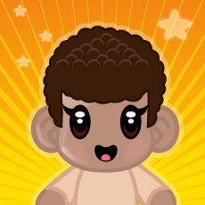

**Instruction:**

Give reasons why the author enjoys working with children?

Could you be a Star Polisher?

|  |
| --- |
|  |
|  |
|  |
|  |
|  |
|  |
|  |
|  |
|  |