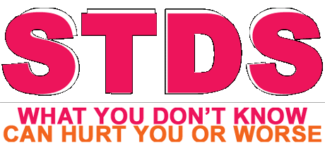
Child Development Unit 2.7
Name ________________________ Period_____ Date_________

Use the following sites only to research the following STDs:
- http://www.mayoclinic.com/health/sexually-transmitted-
diseases-stds/DS01123
- http://www.health.state.mn.us/std

STD = Sexually Transmitted Disease
NOTE: Those with * are STDs most likely to affect unborn baby and mother.

STD | Description | Curable or Not, Explain
*Chlamydia

*Gonorrhea
Trichomoniasis
(trich)
Pubic lice (crabs)

Human
Papillomavirus
(HPV)
*Syphilis

*Genital herpes

Hepatitis B

*Human
Immunodeficiency
Virus (HIV)

From what you have learned thus far, describe how STDs affect mother and baby. Include the specific STDs that are starred.

____________________________________________________________________________________
____________________________________________________________________________________
____________________________________________________________________________________
____________________________________________________________________________________
____________________________________________________________________________________
____________________________________________________________________________________
____________________________________________________________________________________
____________________________________________________________________________________
____________________________________________________________________________________
____________________________________________________________________________________
____________________________________________________________________________________
____________________________________________________________________________________
____________________________________________________________________________________

